**Sub: Microprocessors and Microcontrollers Lab**

**Lab Task 5**

Q1:

ORG 0000H

START MOD Re, #10

MOJ DPTP, #STRING

AGAIN ICLPA

MOJCA A+ DPTR

MOJPIA

ACALL DELAY

ZNC DPTR

DJNZ RO, AGAIN

SJMP START

DELAY MOJ P1,#253

13: MOJ R2, #255

DUNZ

Le R3, LI

DJNE R2, L2

DJNZ R1,13

RET

STRING DB3FH, 064, 5BM, 4FH, 664, 604, 70H, O7h ,7 FM, 6 FH

END

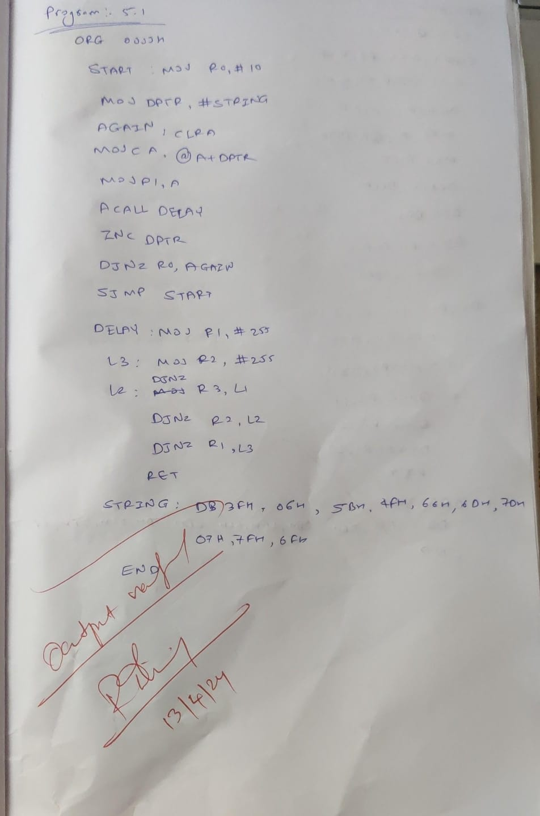

**Q2:** **Write a program to display "SCOPE" on LCD from line 1 position 6**

**Code:**

ORG 0000H MOV A,#38H ACALL CMNWRT ACALL DELAY MOV A,#0EH ACALL CMNWRT ACALL DELAY MOV A,#01H ACALL CMNWRT ACALL DELAY MOV A,#06H ACALL CMNWRT ACALL DELAY MOV A,#80H

ACALL CMNWRT ACALL DELAY MOV A,#'V' ACALL DATWRT ACALL DELAY MOV A,#'I' ACALL DATWRT ACALL DELAY MOV A,#'T' ACALL DATWRT ACALL DELAY

AGAIN: SJMP AGAIN CMNWRT:

MOV P1,A CLR P2.0 CLR P2.1 SETB P2.2 CLR P2.2 RET DATWRT: MOV P1,A SETB P2.0 CLR P2.1 SETB P2.2 CLR P2.2

RET

DELAY: MOV R3,#0FFH MOV R4,#0FFH

MOV R5,#55H HERE: DJNZ R5,HERE

HERE1: DJNZ R4, HERE1 HERE2: DJNZ R3,HERE2 RET END

